Weather Application

The scripting logic under the forecast.js

Here I am making use of the Accuweather API, to request for data on the weather conditions of a given area

* In order to do so, I first need to create a free account there, then when that done, I create a new application

The purpose of creating a new application is just for identification, for them to know who is doing a request and what service does he wants exactly in order by providing the account user with an **API key** for each application created. Note that under the free use of this API, you can only make not more than 50 requests per day

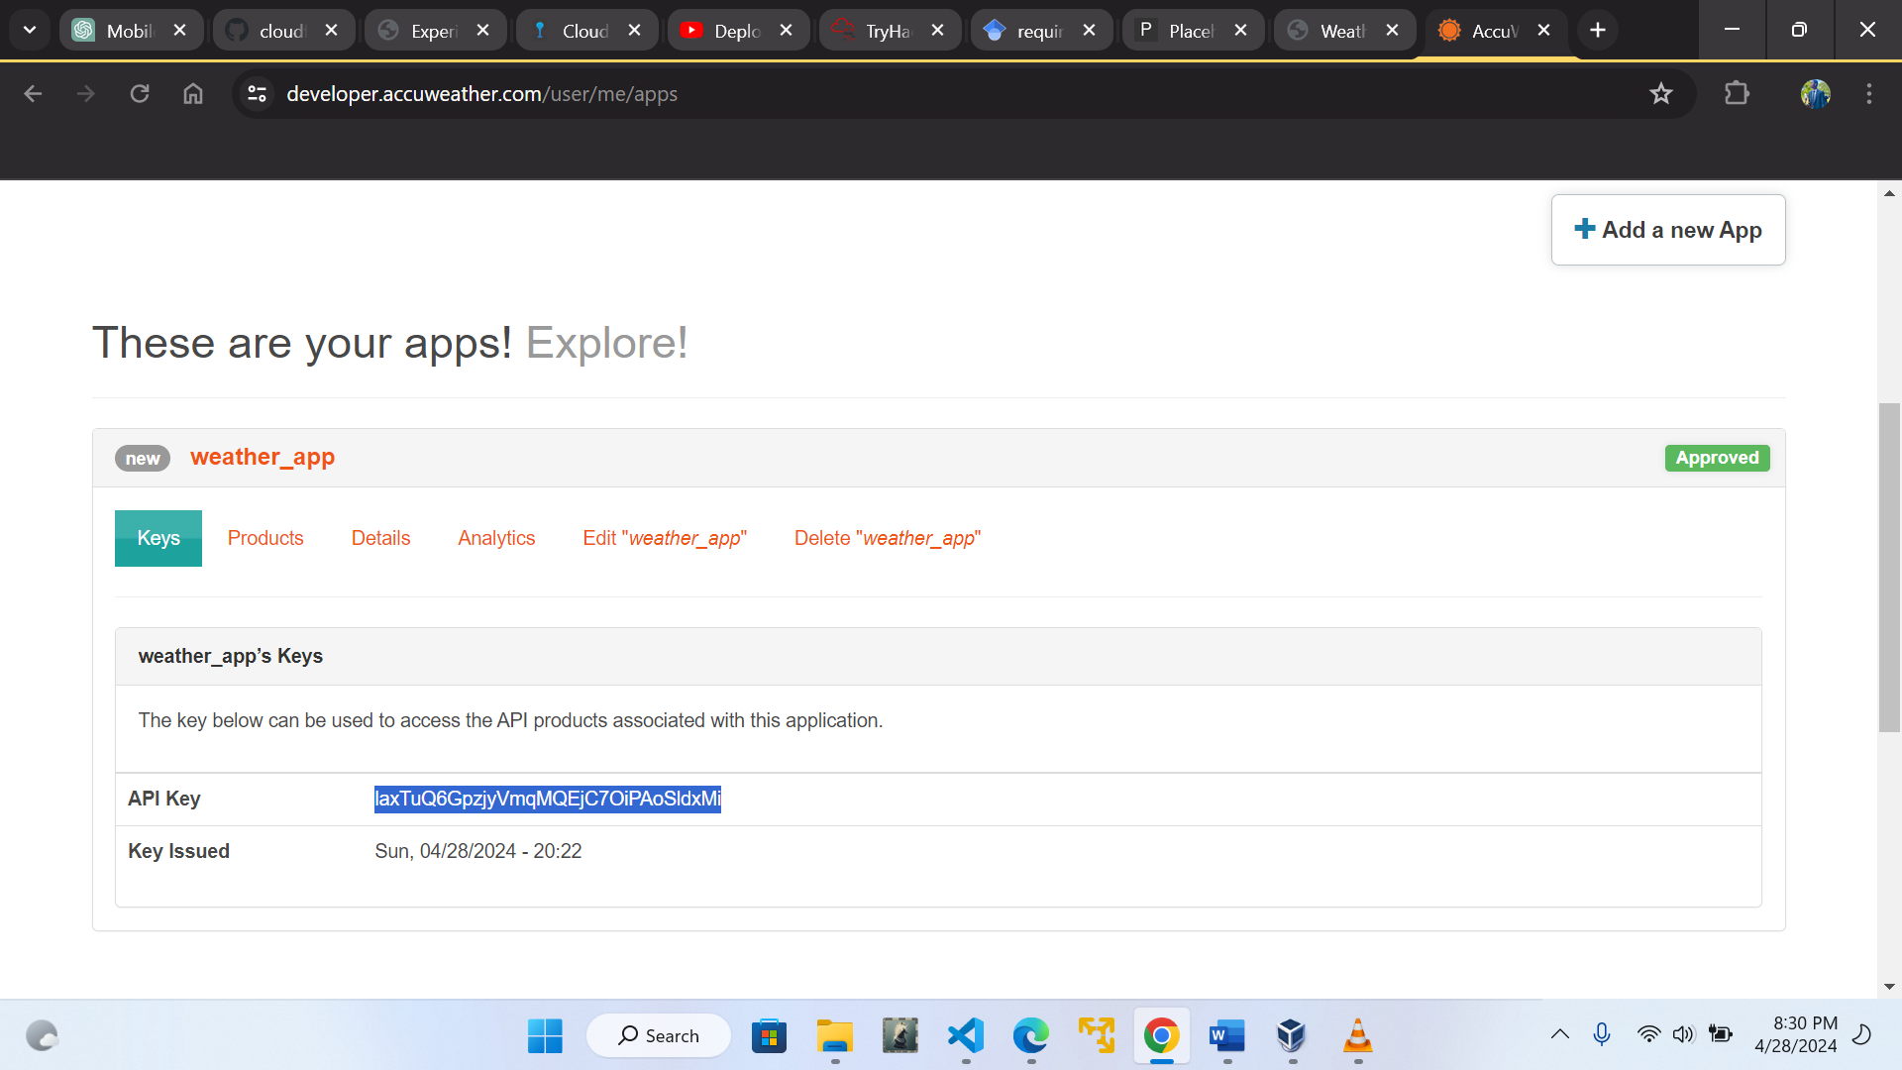

* When requesting data from this API, I’m going to perform that in two discrete phases

The first phase involves requesting a certain endpoint for a given city information. From there we get a city code which is of great use in the second phase

In the second phase, we perform a request for weather information about a specific area with the help of the city code

* The different API endpoints required are provided under the API reference

**The location endpoint and current condition endpoint**

**Consolas, 'Courier New', monospace**